**FACULTY OF MANAGEMENT**

**TRIBHUVAN UNIVERSITY**



**BIM SUMMER PROJECT PROPOSAL: IT 351**

**CAFE POINT OF SALE SYSTEM**

A project proposal submitted for the partial fulfillment of the requirements for the degree of BIM awarded by Tribhuvan University

**Submitted by:**

**Ashika Balami**

**13371/21**

**Submitted To:**

**Department of Computer Science**

**St. Xavier’s College, Matighar, Kathmandu**

**CERTIFICATE OF APPROVAL**

The undersigned certify that they have read and recommended to the Department of Computer Science for acceptance, a Summer Project Proposal entitled “**Cafe Point of Sale System**” submitted by **Ms. Ashika Balami (T.U Roll No:13371/21),** for the partial fulfilment of the requirement for the degree of Bachelor in Information Management awarded by Tribhuvan University.

|  |  |
| --- | --- |
| Er. Rajan Karmacharya  Project Supervisor  CTO, SXC | Mr. Ganesh Yogi  Head of Department  DoCS, SXC |



### INTRODUCTION

A Point of Sale (POS) system is essential for streamlining café operations by automating sales, inventory management, and customer interactions. In a highly competitive market, cafés must ensure efficient service delivery, reduce manual errors, and optimize resource utilization to maintain profitability. Traditional manual processes often lead to inefficiencies, errors, and delays in business operations, making it difficult to track financial transactions, stock levels, and customer preferences accurately.

This project aims to develop a robust, scalable, and efficient POS system using the MERN (MongoDB, Express.js, React.js, Node.js) stack, leveraging its flexibility, speed, and ease of integration. The proposed system will enhance operational efficiency, improve data-driven decision-making, and offer an enhanced customer experience through a modern and interactive user interface.

### PROBLEM STATEMENT

Cafés face significant challenges in handling sales, tracking inventory, and managing customer orders efficiently. Many small businesses still depend on outdated systems or manual record-keeping methods, leading to inaccuracies, delays, and revenue losses. Without an integrated POS system, managing multiple aspects of café operations such as order processing and payment transactions becomes cumbersome and prone to errors. Additionally, cafés often struggle to analyze sales trends and make data-driven decisions due to the absence of a centralized system that provides real-time insights.

A modern, cloud-based POS solution can effectively address these challenges by automating transaction processing, reducing human error, and improving operational efficiency. By leveraging technology to streamline business operations, café owners can focus more on customer satisfaction, optimize resource utilization, and gain competitive advantages in the market. Implementing a POS system with advanced features will not only enhance workflow efficiency but also enable cafés to scale their operations seamlessly.

### OBJECTIVES

The project aims to achieve the fundamental objectives:

* To develop a user-friendly, scalable, and efficient POS system for café operations using the MERN stack.
* To integrate essential features such as order management, real-time billing, sales analytics, and customer data management.

### RESEARCH METHODOLOGY

#### a. Requirement Identification

The first step includes identifying functional and non-functional requirements through stakeholder consultations with café owner and staff.

* **User management**: For cafe owners, and administrators, this system makes it easier to register users, log in, or manage their accounts.
* **Order and service management**: Staffs or operators can manage, classify, or monitor orders of customer and services.
* **Secure Payment Processing**: Implement secure payment gateways to ensure safe and seamless transactions.
* **User friendly UI**: Introduce a user friendly interface that is visually attractive for the convenience of selecting products and services.
* **Data Analysis**: Use data to gain insights on the behavior and preferences of customers, enabling them to make informed choices about product offerings and marketing strategies.

#### b. Feasibility Study

i. . **Technical Feasibility** – A thorough analysis was conducted to determine the suitability of the MERN stack for developing the POS system. The study confirmed that MongoDB provides flexible and scalable database solutions, Express.js and Node.js enable fast and efficient backend processing, and React.js ensures a dynamic and responsive user interface

ii. **Economic Feasibility** – The economic feasibility study analyzed the cost-effectiveness of developing and maintaining the system. It was found that using open-source technologies from the MERN stack significantly reduces licensing costs. Additionally, the projected return on investment for cafés, including time saved in manual operations and improved transaction accuracy, justifies the initial development cost.

iii. **Legal Feasibility** – The system was evaluated for compliance with relevant laws and regulations, such as data protection laws. Legal requirements for digital invoicing, taxation, and financial transaction record-keeping were also considered to ensure that the system adheres to local business regulations.

iv. **Operational Feasibility** – To assess how well the system integrates with existing café workflows, user interviews were conducted. The findings from interview confirmed that employees can quickly adapt to the POS system, reducing training time and ensuring smooth daily operations. Furthermore, features like real-time sales tracking and automated reporting enhance decision-making for café owners.

v. **Schedule Feasibility** – A detailed project timeline was developed to ensure that each phase of development, testing, and deployment could be completed within the allotted timeframe. The study confirmed that the project could be successfully executed within timeframe without compromising quality or functionality.

**c. Data Collection Strategy**

* Conducting interviews with café owners and employees.
* Deploying customer questionnaires to assess expectations and usability requirements.
* Reviewing existing POS case studies.

### LITERATURE REVIEW

A Point of Sale (POS) system is a crucial technology in modern retail and food service industries, allowing businesses to efficiently manage sales transactions, inventory, and customer interactions. Various studies and implementations of POS systems have highlighted their impact on operational efficiency, financial management, and customer satisfaction(Geraldine B. Mangmang, 2018).

**5.1 Traditional POS Systems vs. Cloud-Based POS Systems**

Traditional POS systems are typically on-premise solutions that require dedicated hardware and local servers. These systems have been used for decades but come with limitations such as high maintenance costs, lack of remote access, and hardware dependency (Bresler et al., 2021). Cloud-based POS systems, on the other hand, leverage internet connectivity and cloud storage to enable real-time access, data security, and integration with other business applications (Reddy & Kumar, 2022).

**5.2 Open-Source and Custom POS Systems**

Many businesses prefer open-source or custom-built POS solutions to avoid vendor lock-in and have better control over system functionalities. For instance, Odoo POS and Floreant POS are open-source solutions that provide customizable options for small and medium-sized enterprises (Gómez et al., 2019). However, these solutions require significant technical expertise for deployment and maintenance.

**5.3 Mobile and AI-Driven POS Systems**

The emergence of mobile and AI-powered POS systems has transformed how businesses interact with customers. AI-driven analytics can provide insights into sales trends, customer behavior, and inventory management (Brown et al., 2020). Mobile POS solutions, such as Shopify POS and Square POS, allow businesses to process transactions on-the-go using smartphones or tablets, increasing operational flexibility (Taylor & Green, 2021).

**5.4 Security and Compliance in POS Systems**

Security is a major concern for POS systems, especially regarding payment processing, user authentication, and data privacy. Research by Patel et al. (2021) highlights that compliance with PCI-DSS standards is critical for securing payment transactions. Cloud-based POS solutions often integrate multi-factor authentication (MFA), tokenization, and end-to-end encryption to enhance security.

Blockchain-based POS solutions have also been explored for their ability to provide tamper-proof transaction records and increased transparency (Choi & Lee, 2023). However, widespread adoption remains limited due to scalability concerns.

**5.5 Existing Point of Sales System**

Existing Point of Sale (POS) systems in the market offer various features tailored to business needs. Retail Man POS transforms a personal computer into a fully functional POS system with inventory management and accounting capabilities by integrating hardware like barcode scanners and cash drawers. POS Maid is a user-friendly solution compatible with barcode scanners and touch screens, offering automated tax calculations, customer data storage, and employee payroll tracking. Free Deluxe POS 2.0 is a free Windows-based software supporting cash drawers, barcoding, and purchase order creation, making it ideal for both single-PC setups and multi-terminal networks. These systems highlight the diverse functionalities available in modern POS software, catering to different business sizes and operational requirements.

Cloud-based POS systems have improved retail operations but struggle with service disruptions during internet outages. To address this, a new POS system integrates Blockchain and Edge Computing for enhanced security, trust, and resilience. By using cash registers as blockchain nodes, transactions are securely stored and synchronized with the cloud once the connection is restored. This approach reduces internet dependency and ensures seamless operations with minimal manual intervention(Hu et al., 2018).

**5.6 Gaps and Future Trends in POS Systems**

Despite the advancements in POS technology, there are still challenges, including integration issues, high initial costs, and reliance on internet connectivity (Hernandez et al., 2022). Future research is focusing on AI-powered automation, blockchain integration, and edge computing to further enhance POS capabilities.

### PROPOSED TOOLS

**Programming Language & Frameworks:** MERN Stack (MongoDB, Express.js, React.js, Node.js) – Selected for its seamless full-stack JavaScript integration, flexibility, and scalability. The use of a single language (JavaScript) across the entire stack enables smooth data flow between the frontend, backend, and database, reducing development time and complexity.

**Database:** MongoDB – A NoSQL database optimized for handling large-scale transactions and real-time data. Its document-based storage model provides flexibility in managing unstructured and semi-structured data, which is ideal for handling dynamic inventory and customer order information in a café setting.

**Frontend:** React.js – Chosen for its component-based architecture, which enhances code reusability and maintainability. React.js ensures a fast and interactive user experience, allowing cashiers and staff to process transactions and orders efficiently with a responsive interface.

**Backend:** Express.js & Node.js – A powerful combination that offers a lightweight, non-blocking, event-driven architecture suitable for high-performance applications. Node.js allows handling multiple concurrent transactions efficiently, while Express.js simplifies API development and request handling.

### TIME SCHEDULE/GANTT CHART

A structured project timeline will be developed using a Gantt chart, covering the following phases:

|  |  |  |  |
| --- | --- | --- | --- |
| **Phases** | **Start Date** | **End Date** | **Duration (in days)** |
| Brainstroming | 2024-12-04 | 2024-12-20 | 16 |
| Requirement | 2024-12-21 | 2025-01-05 | 15 |
| Planning | 2025-01-06 | 2025-01-15 | 9 |
| Development | 2025-01-20 | 2025-03-30 | 69 |
| Testing | 2025-04-01 | 2025-04-07 | 6 |
| Maintainance | 2025-04-08 | 2025-04-14 | 6 |
| Doumentation | 2025-04-15 | 2025-04-22 | 7 |

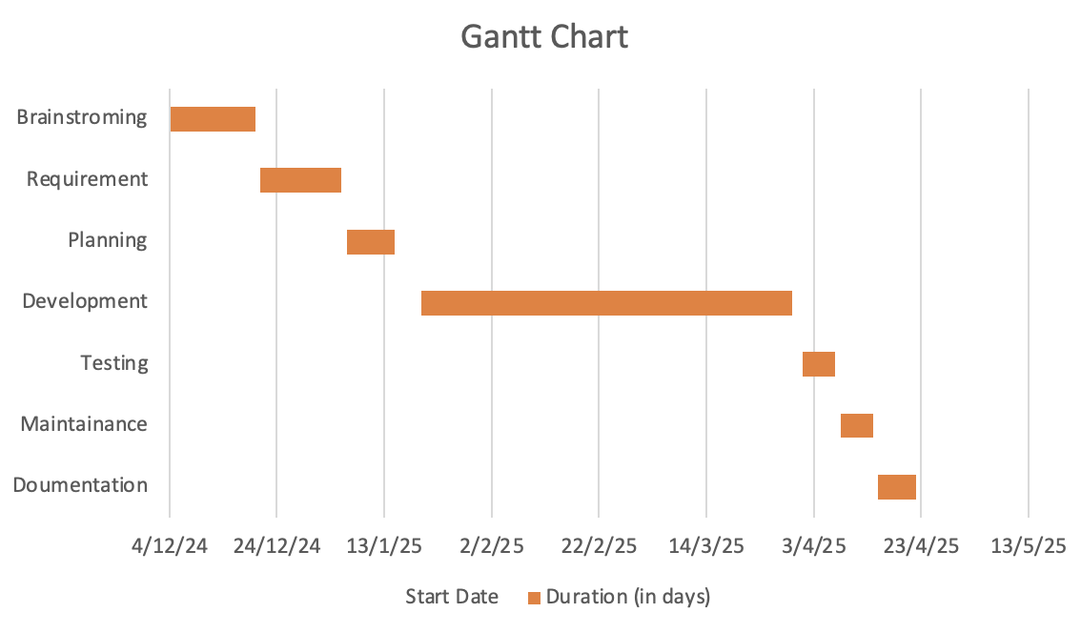

### DELIVERABLES/EXPECTED OUTCOME

### The deliverables and expected outcomes of the project include the development of a fully functional café Point of Sale (POS) system using the MERN stack (MongoDB, Express.js, React.js, and Node.js). This system will be designed to streamline the daily operations of the café, offering seamless transaction processing and management. Key features will include integrated modules for billing, allowing for quick and accurate customer transactions; order tracking, which will provide real-time updates on orders, enabling efficient management of supplies; and sales analytics, which will generate insightful reports to help café management make informed decisions on sales trends and performance. The system will be user-friendly, scalable, and optimized for both front-end and back-end performance, ensuring smooth operation for staff and effective monitoring for managers.

<https://dribbble.com/shots/25471101-Green-Grounds-Coffee-Point-of-Sales-Cafe-POS-system>

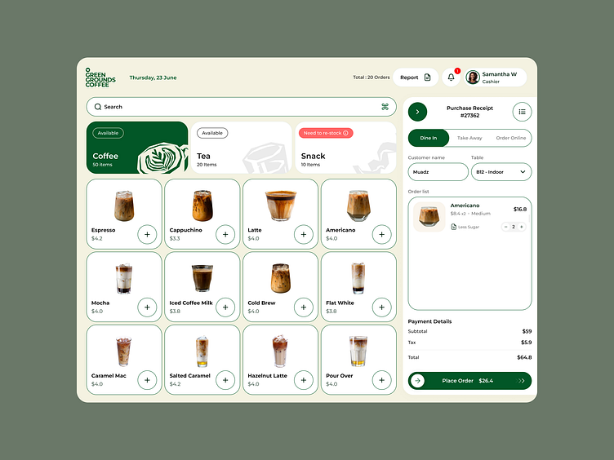

### REFERENCES

**Bresler, S., Nelson, M., & Carter, J. (2021).** A comparative study of traditional and cloud-based POS systems. Journal of Business Technology, **45**(3), 121-135.

**Brown, L., Williams, R., & Smith, T. (2020).** AI-driven analytics in modern point of sale systems. International Journal of AI in Business, **12**(2), 67-89.

**Choi, K., & Lee, M. (2023).** Enhancing POS security through blockchain technology. Cybersecurity & Digital Commerce Review, **9**(4), 200-220.

**Gómez, A., Patel, R., & Singh, P. (2019).** Open-source POS systems: Challenges and opportunities. Software Engineering Journal, **33**(6), 415-430.

**Hernandez, J., Park, Y., & Lopez, C. (2022).** The future of POS systems: Trends and challenges. Technology & Innovation Review, **15**(1), 98-115.

Geraldine B. Mangmang. (2018). Development and Implementation of Point of Sale System (POS): Profitability Measurement for Retail Business. *Journal of Educational and Human Resource Development (JEHRD)*, *6*, 220–226. https://doi.org/10.61569/5tc08q53

Hu, B., Xie, H., Ma, Y., Wang, J., & Zhang, L. J. (2018). A robust retail POS system based on blockchain and edge computing. *Lecture Notes in Computer Science (Including Subseries Lecture Notes in Artificial Intelligence and Lecture Notes in Bioinformatics)*, *10973 LNCS*, 99–110. https://doi.org/10.1007/978-3-319-94340-4_8

**Patel, V., Kumar, S., & Davis, M. (2021).** Data security in POS systems: PCI-DSS compliance and best practices. Journal of Cybersecurity Research, **27**(5), 345-360.

**Reddy, B., & Kumar, N. (2022).** Cloud-based POS systems: A game changer for small businesses. Retail Management Review, **40**(1), 50-78.

UKEssays. (2018). *Literature Review On Point Of Sales System.* <https://www.ukessays.com/essays/computer-science/literature-review-on-point-of-sales-system.php?vref=1>